# Name: Huynh Ngoc Tuyen StudentID: s3818311

## Activity 1 - Human Computer Interface (HCI) Analysis

## 

### Crown Casino: [[http://www.crownmelbourne.com.au](http://www.crownmelbourne.com.au/)]:

Here is a snapshot of Crown Casino's home page:

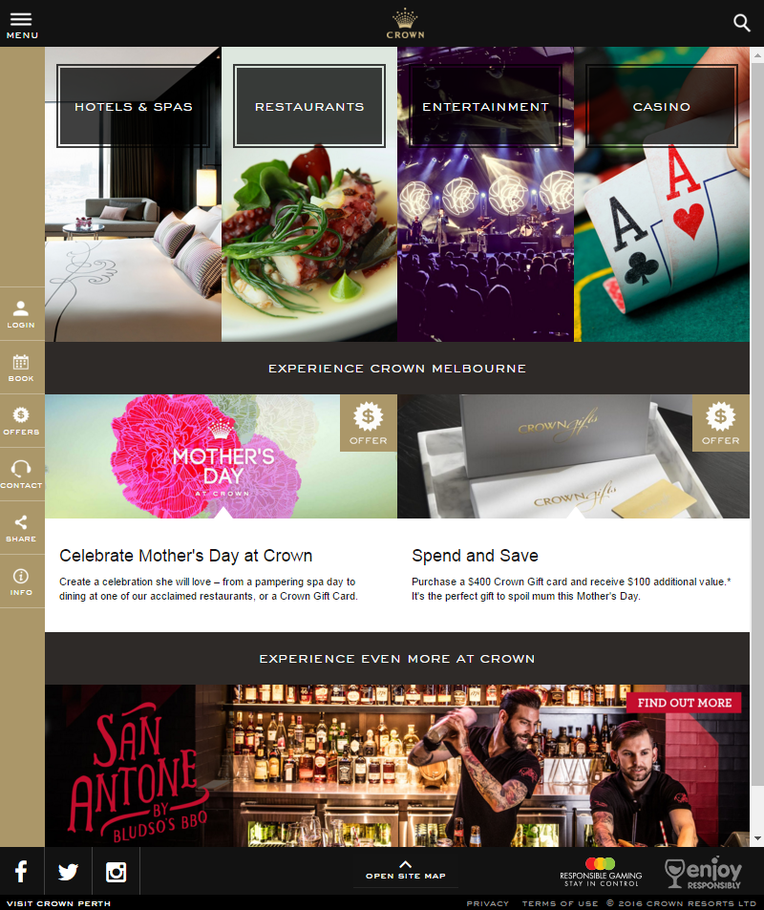

Discuss the following questions:

* What are the four business areas they are promoting on the home page? What types of audiences are they appealing to?
  + Four business areas:
    - Hotels and Spa
    - Restaurants
    - Entertainment
    - Casino
  + I think their targeted audiences are wealthy people who wants a luxurious experience
* Is the content on this home page (landing page) general in nature? Does it capture all audiences without alienating anyone?
* Are there any issues with contrast that will impact the visually impaired? Have any compromises been made in the name of stylish design? Test your color choices here: <https://contrast-ratio.com/>
  + The background color navigation bar on the left has poor contrast against the small white text, making it a bit hard to properly read the navigation bar button labels. Otherwise the white on black are much easier to read
  + I think the yellow-brown-ish color design was intentional as it gives off a feeling of luxury and wealth. They

* Is the interface at all confusing? Does this website pose any problems for those with mobility or intellectual disabilities?

Crown Casino charges rent from their commercial tenants. The success of Crown's business depends on the success of the tenants' businesses and so it makes sense for Crown to promote their tenants' businesses within their website. Below is a screenshot from the restaurant's and food market businesses category:

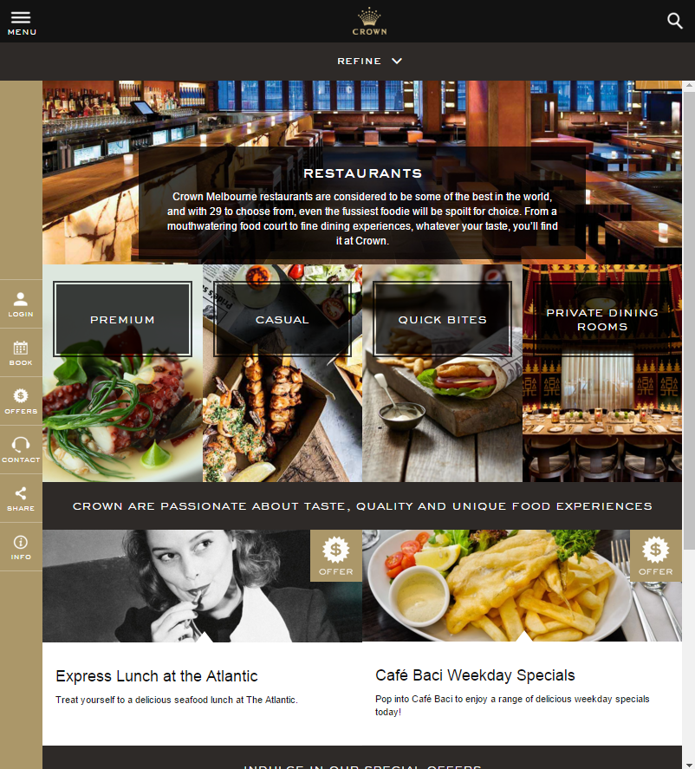

The content on this landing page is more specific: relating to places to eat, but it is still a landing page for 4 general types of audience. Name the 4 types of audience and is there any significance with the placement of each group of restaurants on the page?

Think about what might attract each group and what would "scare" them away? In particular, how does it appeal to those looking for a lavish place to eat (eg Heston Blumenthal's restaurant?) without intimidating those who are on a budget and just want to visit KFC or McDonalds?